The Impact of Social Media on Academic Success

A Report on the Effects of Social Media on Students' Academic Performance

Submitted by: Wajiha Nazir
Roll Number: 25K-3021

Contents
1. Introduction 2
2. Students' Social Media Use 3
2.1 Regular Use Habits 3
2.2 Time Spent 3
2.3 Intention of Use 3
3. Social Media's Positive Effects on Learning 3
3.1 Collaboration and Communication 3
3.2 Access to Learning Material 3
3.3 Networking Opportunities 3
3.4 Awareness and Information 3
4. Adverse Impact of Social Media on Academic Performance 3
4.1 Distraction and Procrastination 3
4.2 Diminution of Academic Performance 4
4.3 Mental Health Complications 4
4.4 Disrupted Sleep Patterns 4
5. Research Findings and Statistics 4
5.1 Global Perspective 4
5.2 Academic Correlation 4
5.3 Local Context 4
6. Case Study: University Students 5
7. Balanced Usage Recommendations 5
7.1 Time Management 5
7.2 Use of Academic Platforms 5
7.3 Digital Wellbeing Tools 5
7.4 Institutional Support 5
8. Conclusion 5
9. References 6

The Effect of Social Media on Academic Achievement

1. Introduction

Social media like Facebook, Instagram, TikTok, Twitter, and WhatsApp are integral to daily life for most students these days. Social media are applied for instant messaging, sharing of information, as well as entertainment. Teachers, parents, and policymakers are increasingly worried about their impact—both negative and positive—on academic outcomes. This report discusses the positive and negative impacts of social media on students based on research studies and noted realities.

2. Students' Social Media Use

2.1 Regular Use Habits
Empirical evidence indicates that more than 80% of university students globally use one or several social media sites daily. (Junco, 2019)

2.2 Time Spent
On average, students use 2–4 hours of their daily time browsing, sharing, or engaging in online forums.

Social Media Platform | Average Daily Time (hours) | Primary Use (Study / Entertainment)
Facebook | 1.5 | Mixed
WhatsApp | 2.0 | Study groups + chatting
Instagram | 2.5 | Entertainment
TikTok | 3.0 | Entertainment
Table 1: Average student time spent on different social media platforms per day.

2.3 Intention of Use
Social media is applied for information, study collaboration, and entertainment purposes, yet extensive participation may create distraction and lower productivity.

3. Social Media's Positive Effects on Learning

3.1 Collaboration and Communication
Students can form study groups through applications such as WhatsApp or Facebook, enabling real-time sharing of notes, resources, and ideas.

3.2 Access to Learning Material
YouTube and LinkedIn Learning offer free tutorials, lectures, and skill-based material that complement in-class learning.

3.3 Networking Opportunities

Social media links students with peers, instructors, and professionals from all over the world, providing opportunities for research and career advancement.

3.4 Awareness and Information
Students stay updated with current affairs, world events, and new technologies.

4. Adverse Impact of Social Media on Academic Performance

4.1 Distraction and Procrastination
Constant notifications and entertainment functions tend to gobble up study hours.

4.2 Diminution of Academic Performance
Research indicates heavy use of social media is linked to poor GPA.

4.3 Mental Health Complications
Overindulgence, particularly late at night, may result in stress, anxiety, and low self-esteem based on comparison, which adversely impacts concentration.

4.4 Disrupted Sleep Patterns
Late-night browsing interferes with sleep, causing drowsiness and decreased concentration at school.

5. Research Findings and Statistics

5.1 Global Perspective

According to a Pew Research Center (2023) survey, 62% of students conceded social media distracted them from study. (Center, Students and Social Media Usage, 2023)

Figure 1: Impact of daily social media usage on student performance.

5.2 Academic Correlation
According to the University of Maryland, students who restricted use to less than one hour a day were more academically successful than frequent users. (Maryland, 2022)

5.3 Local Context
In Pakistan, HEC surveys have ascertained that Facebook and WhatsApp are the most frequently used platforms for academic work. ((HEC), 2022)

6. Case Study: University Students
A research study at a nearby university found that students who used social media for academic purposes (e.g., liking educational groups or following science pages) performed better than students who used it for entertainment. This illustrates that the effectiveness of social media is heavily dependent on usage.
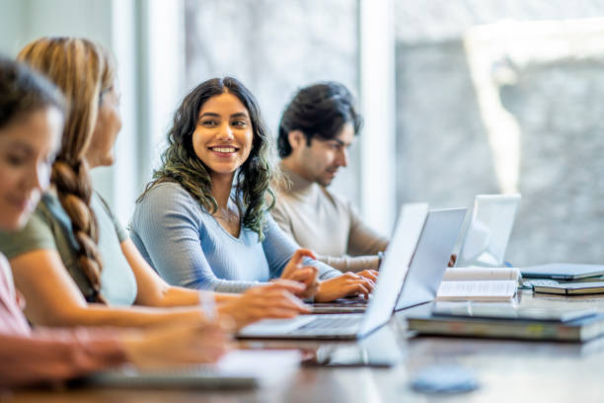
Figure 2: University students engaging in collaborative study through social media

7. Balanced Usage Recommendations

7.1 Time Management
Students should limit non-academic social media use daily.

7.2 Use of Academic Platforms
Websites such as ResearchGate, LinkedIn, and Google Scholar should be promoted for productive use.

7.3 Digital Wellbeing Tools
Applications like Focus Mode and Screen Time can assist in managing distractions.

7.4 Institutional Support
Schools and universities should conduct awareness sessions on responsible social media usage.

8. Conclusion
Social media has a dual effect on students' academic performance. It ensures communication, sharing of information, and learning opportunities, but unregulated usage can reduce focus, efficiency, and mental well-being. By taking a balanced approach—with a mindset to utilize social media as a learning tool and not as a distraction—students can gain the maximum advantages of social media while losing the minimum.

9. References
(HEC), H. E. (2022). Digital Media and Education in Pakistan. Islamabad, Pakistan: HEC.
Center, P. R. (2023). Students and Social Media Usage. Washington, DC: Pew Research Center.
Center, P. R. (2023). Students and Social Media Usage. Washington, DC: Pew Research Center.
Junco, R. (2019). The Relationship Between Frequency of Facebook Use, Participation in Facebook Activities, and Student Engagement. Journal of Applied Developmental Psychology, 19–29.
Maryland, U. o. (2022). Impact of Social Media on Academic Achievement. Maryland, USA: University of Maryland Press.

